Reopening: Four-Phase Approach
​​​​​The Massachusetts economy will be reopened using a four-phase approach, based on public health guidance.

Overview
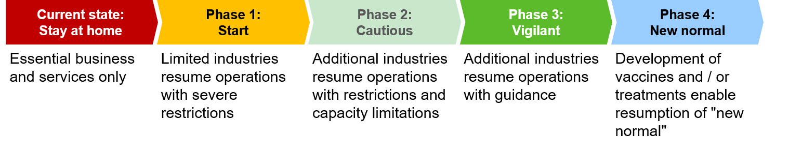
The goal of this phased reopening plan is to methodically allow businesses, services, and activities to resume, while avoiding a resurgence of COVID-19 that could overwhelm our healthcare system and erase the progress we’ve made so far.
- Each phase will last a minimum of three weeks and could last longer before moving to the next phase
- If public health data trends are negative, specific industries, regions, and/or the entire Commonwealth may need to return to an earlier phase
- The Commonwealth will partner with industries to draft Sector-Specific Protocols in advance of future phases (example: restaurant specific protocols will be drafted in advance of Phase 2)
- If we all work together to defeat COVID-19, we can proceed through each phase

Framework
The Baker-Polito Administration's data-driven approach to reopening the economy used a framework that considered the public health risk and the economic benefit of reopening each of the closed sectors of our economy. In addition to this framework, the Baker-Polito Administration looked to what other states are doing, including our immediate neighbors and those that were similarly impacted by COVID-19.
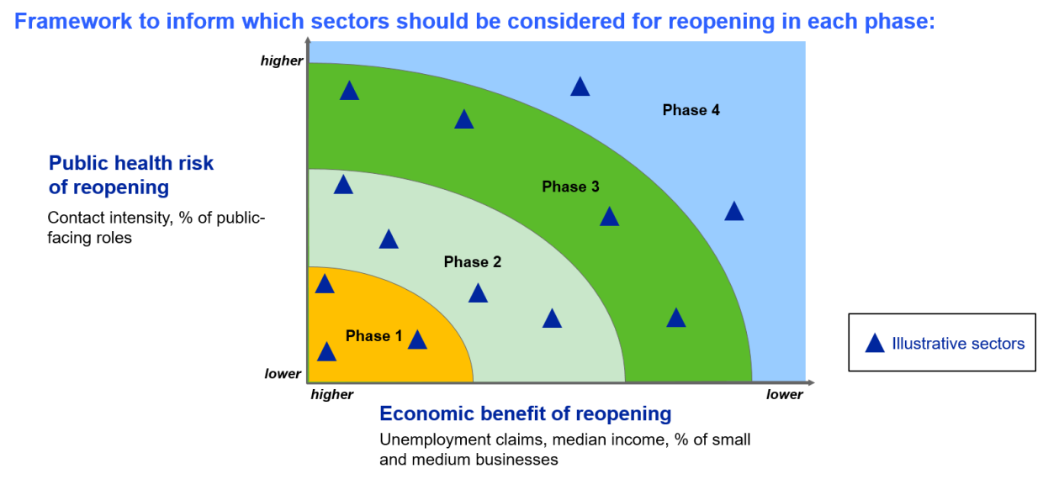

Phased approach and reopening summary plan